

Option A Student Build Card
Scratch rule-based chatbot | Build from your Part 2 blueprint
BUILD RULE
Keep the Part 2 worksheet open. Replace placeholders only with the approved wording. Working logic before decoration.

Step | Do this
1 START | Open the prepared Scratch starter/reference. Rename the project with your anonymous group code.
2 INTRODUCE | Under when green flag clicked, add the approved chatbot name, target user and purpose.
3 SHOW CHOICES | Say the category names: 1, 2, 3 and 0 to see limits. Add ask and wait.
4 ROUTE 1–3 | Use nested if/else blocks. Compare answer with 1, 2 and 3 using the green diamond = block. Add the exact approved response in each branch.
5 LIMITS | Before the final fallback, add answer = 0 and the exact limitation/safety response.
6 FALLBACK | In the final else, add the approved fallback and show how to continue.
7 PART 1 FEATURE | Check that the planned Part 1 feature is visible in the exact message or branch named in Part 2.
8 VERIFY | Use Runs / Technical repair needed / Not yet complete in the Build Record. Do not judge quality.
9 SAVE | Save, reopen once, record the link/filename and complete the Part 4 Test Brief.

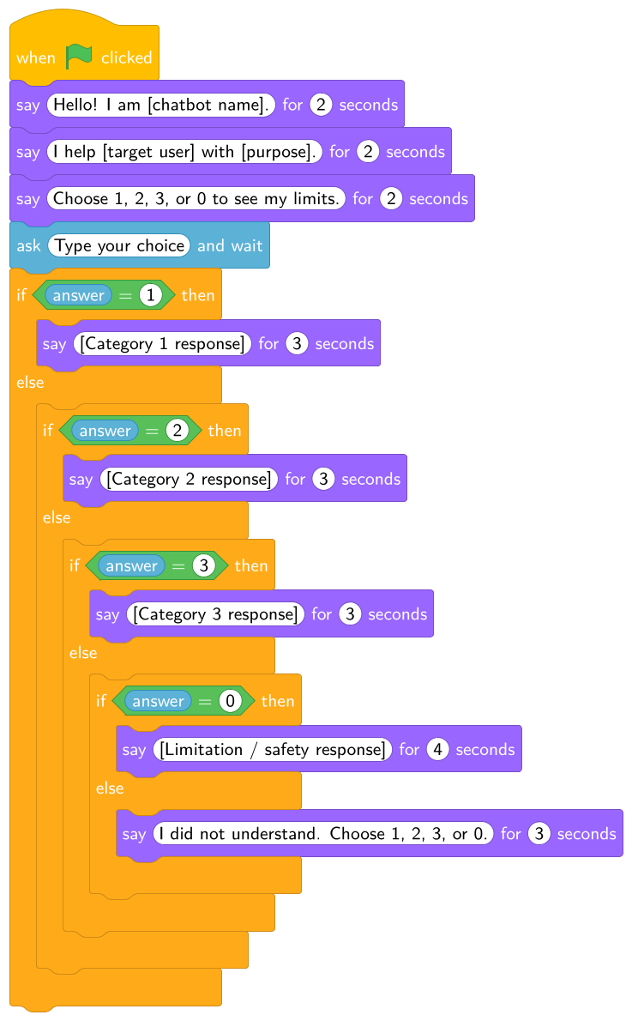
Minimum structure: 1–3 content routes, 0 limits route, any other input fallback.
Before you finish
☐ Starts and resets ☐ Routes 1–3 run ☐ 0 shows limits ☐ Other input shows fallback ☐ Part 1 feature is present ☐ Saved ☐ Test Brief complete

